Book

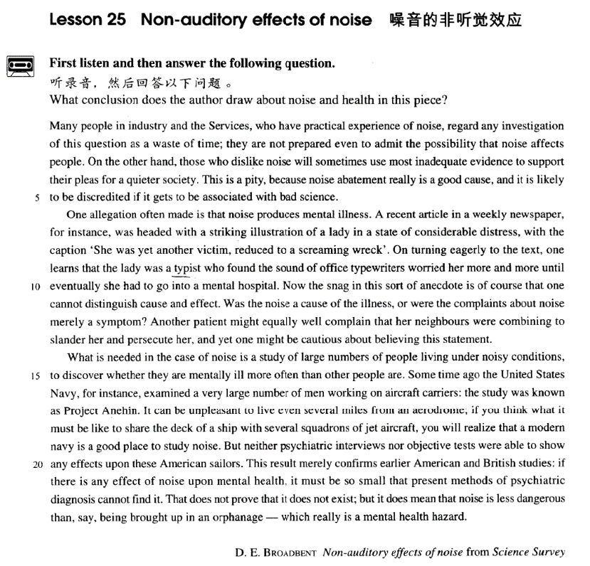

课文

Many people in industry and the Services, who have practical experience of noise,

在工业部门工作和在军队中服役的许多人对噪声音有切身的体会，

regard any investigation of this question as a waste of time;

他们认为对这个问题进行调查中浪费时间，

they are not prepared even to admit the possibility that noise affects people.

甚至不愿承认噪音可能对人有影响。

On the other hand, those who dislike noise will sometimes use most inadequate evidence to support their pleas for a quieter society.

另一方面，那些讨厌噪音的人有时会用不充分的证据来支持他们希望有一个较为安静的社会环境的要求。

This is a pity, because noise abatement really is a good cause, and it is likely to be discredited if it gets to be associated with bad science.

要求减少噪音是件好事，但是如果与拙劣的科学掺杂在一起的话，就不会被人们所信任，这是很遗憾的。

One allegation often made is that noise produces mental illness.

常见的一种指责是，噪音能引起精神病。

A recent article in a weekly newspaper, for instance, was headed with a striking illustration of a lady in a state of considerable distress,

例如，最近一家周报刊登了一篇文章，文章上方有一幅引人注目的插图，是一位表情沮丧的女子。

with the caption 'She was yet another victim, reduced to a screaming wreck'.

图的文字说明：“她是又一个受害者，成了只会尖叫的可怜虫。”

On turning eagerly to the text, one learns that the lady was a typist who found the sound of office typewriters worried her more and more until eventually she had to go into a mental hospital.

当人们急切地看完正文后，便知道这女子是个打字员，办公室打字机的声音使她越来越烦，最终住进了精神病医院。

Now the snag in this sort of anecdote is of course that one cannot distinguish cause and effect. Was the noise a cause of the illness, or were the complaints about noise merely a symptom?

这类奇闻的疑难之处是无法区别因果关系。是噪音引起了（精神）病呢，还是（精神）病的症状之一是对噪音的抱怨？另有一位病人可能同样有理由抱怨说，她的邻居们正在联合起来对她进行诽谤和迫害，

Another patient might equally well complain that her neighbours were combining to slander her and persecute her, and yet one might be cautious about believing this statement.

不过，人们不会轻信她的抱怨。对于噪音问题，需要对大量生活在噪音中的人进行研究，

What is needed in the case of noise is a study of large numbers of people living under noisy conditions, to discover whether they are mentally ill more often than other people are. Some time ago the United States Navy, for instance,

看一看他们是否比其他人更易患精神病。例如，美国海军前些时候调查了许多在航空母航上工作的人，

examined a very large number of men working on aircraft carriers: the study was known as Project Anehin.

这次调查被称之为：“安内英工程”。即使住在离机场几英里以外的地方，机场的噪音也会使人难受。

It can be unpleasant to live even several miles from an aerodrome; if you think what it must be like to share the deck of a ship with several squadrons of jet aircraft,

因此，如果你能想像出和几个中队的喷气机同在一个甲板上是什么滋味儿的话，你就会认识到现代海军是研究噪音的好地方。

you will realize that a modern navy is a good place to study noise. But neither psychiatric interviews nor objective tests were able to show any effects upon these American sailors.

但是，不管进行精神病学的调查访问，还是进行客观的测试，都不能显示噪音对这些美国水兵有任何影响。这个结果只不过证实了美国和英国早些时候的研究结论：

This result merely confirms earlier American and British studies: if there is any effect of noise upon mental health, it must be so small that present methods of psychiatric diagnosis cannot find it.

如果噪音对精神健康有影响的话，那也一定是微乎其微，以致现代的精神病诊断方法还发现不了。

That does not prove that it does not exist; but it does mean that noise is less dangerous than, say being brought up in an orphanage -- which really is a mental health hazard.

这并不是证实不存在噪音对健康的影响。但它确实说明，噪音的危险性 -- 比如说 -- 比在孤儿院长大所受的危害要小一些，孤儿院才是真正危害精神健康的地方。

词汇讲解

Lesson 25

**Non-auditory effects of noise**

auditory ['ɔ:ditəri]

adj. 听觉的

auditory adj. relating to the ability to hear 听觉的

the auditory nerve “aud” = to hear

audible audience

audio-visual audit

auditor audition

audiphone auditorium plea [pli:]

n. 请求

plea n. a request that is urgent or full of emotion 请求，恳求 = pleading plea for …

The police ignored her pleas for help.

On the other hand, those who dislike noise will sometimes use most inadequate evidence to support their pleas for a quieter society.

In response to renewed pleadings, Bruce stopped. pleading for …

He was deaf to her pleadings for forgiveness.

plead v. 1. to ask for something that you want very much, in a sincere and emotional way 请求，恳求

plead for …

Civil rights groups pleaded for government help. plead with sb. (to do sth.)

Moira pleaded with him to stay.

plead v. 2. to give a particular excuse for your actions 以……为借口

plead ignorance / illness / insanity …

No one can plead ignorance of a subject any longer, for there are countless do-it-yourself publications.

abatement [ə'beɪtmənt]

n. 减少，减弱

abatement n. a reduction in sth. harmful or unpleasant 减少，减弱

noise / pollution abatement

This is a pity, because noise abatement really is a good cause, …

abate v. to become less strong 减少，减弱The storm / wind / rain has started to abate. ebb

Our enthusiasm soon began to ebb. subside

The storm began to subside.

The applause / pain gradually subsided.

I wanna hold you till I die, till we both break down and cry. I wanna hold you till the fear in me subsides.

wane

My enthusiasm for the project was waning. allegation [7ælɪ'geɪʃən]

n. 声称，断言

allegation n. a statement that someone has done something wrong or illegal, but that has not been proved （没有依据的）声称，断言

One allegation often made is that noise produces mental illness.

an allegation that he had been dishonest

Several newspapers made allegations of corruption in the city's police department.

Mr. Singh has strongly denied the allegations of sexual harassment.

allege v. to say that something is true or that someone has done something wrong, although it has not been proved （没有依据地）声称，断言

It was alleged that the policeman had accepted bribes.

The water is alleged to be polluted with mercury.

Was the philosopher who refused to look through Galileo's telescope more culpable than those who alleged that the spiral nebulae observed with Lord Rosse's great telescope in the eighteen-forties were scratches left by the grinder?

slander

['slɑ:ndə(r)] ['slændə(r)]

v. 诽谤，中伤

slander v. to say false things about someone in order to damage other people's good opinion of them 诽谤，中伤

He angrily accused the investigators of slandering both him and his

family.

slur / defame / traduce / libel sb.

She accused the programme of slurring the company's name. The article is an attempt to defame an honest man.

We have been traduced in the press as xenophobic bigots.

He claimed he had been libeled in an article the magazine had published. regard sth. as a slander / slur on …

Parents are often upset when their children praise the homes of their friends and regard it as a slur on their own cooking, or cleaning, or furniture, and often are foolish enough to let the adolescents see that they are annoyed.

Many people in industry and the Services, who have practical experience of noise, regard any investigation of this question as a waste of time; they are not prepared even to admit the possibility *that noise affects people*. service n. department of people employed by the government or a public organization 政府部门

the Civil Service 政府的行政部门

the Diplomatic Service 外交部门

the National Health Service 国民保健部门

This modern faith in medicines is proved by the fact that the annual drug bill of the Health Services is mounting to astronomical figures and shows no signs at present of ceasing to rise.

a waste of …

Being unemployed is such a waste of your talents.

Many believe that state aid is a waste of taxpayers' money. What a waste of all that good work!

be prepared / ready to do sth.

Why people are prepared to tolerate a four hour journey each day for the dubious privilege of living in the country is beyond me.

Relatively few people are prepared to sacrifice up to a third of their holidays for the pleasure of travelling on a ship.

…, and the doctor in charge of the department is only too ready to provide them with these requirements.

be not prepared to admit the possibility that …

造句：很多人把调查转基因食品 (GM foods) 看作是浪费时间，他们甚至都不愿意承认转基因食品可能对人有影响。

Many people regard any investigation of GM foods as a waste of time; they are not prepared even to admit the possibility that GM foods affects people.

On the other hand, those who dislike noise will sometimes use most inadequate evidence *to support their pleas for a quieter society*.

on the one hand ... on the other (hand) ... (used to indicate contrasting points of view, opinions, etc 用以引导出相互矛盾的观点﹑ 意见等) 一方面，另一方面

I'd like to eat out, but on the other hand I should be trying to save money. Even really honest people are often made to feel guilty. The hardened professional smuggler, on the other hand, is never troubled by such feelings, even if he has five hundred gold watches hidden in his suitcase. 造句：另一方面，那些不喜欢转基因食品的人有时会使用极其不充分

的证据来支持他们对没有这种东西的日常饮食的需求。

On the other hand, those who dislike GM foods will sometimes use most inadequate evidence to support their pleas for a diet without them.

This is a pity, because noise abatement really is a good cause, and it is likely to be discredited *if it gets to be associated with bad science*.

cause n. 1. 理由 [C] & [U]

Our vicar is always raising money for one cause or another, but he has never managed to get enough money to have the church clock repaired.

One would expect them to know their parts by heart and never have cause to falter.

cause n. 2. 事业 [C]

Her life was devoted to the cause of justice.

discredit v. to cause people to stop respecting someone or believing in an idea or person 怀疑，质疑

Evidence of links with drug dealers has discredited the President.

Some of Freud's theories have now been discredited.

get to do sth. 有机会……

We got to meet all the stars after the show.

She gets to travel all over the place with her job. get to like / know / understand …

渐渐开始……

It'll take a while for you to get to know everyone. After a while, I got to like him.

造句：发展转基因食品的确是个好事业，但是如果它有机会与拙劣的

科学联系起来，就容易引起人们的不信任。

The development of GM foods really is a good cause, but it is likely to be discredited if it gets to be associated with bad science.

One allegation often made is *that noise produces mental illness*. produce v. to cause a particular result or effect 引起，产生，导致a rise in sea-level produced by climatic change

As a policy, it did not produce the desired effect.

造句：常见的一种指责是，转基因食品能引起潜在的风险。

One allegation often made is that GM foods produce potential risks.

A recent article in a weekly newspaper, *for instance*, was headed with a striking illustration of a lady in a state of considerable distress, with the

caption *'She was yet another victim, reduced to a screaming wreck'*.

head v. if a page is headed with a particular name, title, image etc, it has it

on the top

The page was headed 'Expenses'.

The information sheet was headed Medical Insurance.

striking adj. unusual or interesting enough to be easily noticed 醒目的， 引人注意的

She bears a striking resemblance to her older sister.

illustration n. 1. a picture in a book, article etc, especially one that helps you to understand it （书或文章中的）插图

a children's book with beautiful illustrations

illustration n. 2. a story, an event or an example that clearly shows the truth about sth. 例证，例子

The statistics are a clear illustration of the point I am trying to make.

One apt illustration of this point involves the rapid development of Japan. Let me, by way of illustration, quote from one of her poems.

in a state of …

He was in a state of permanent depression.

Without it, nothing could ever be brought to a conclusion; everything would be in a state of chaos.

caption n. words printed above or below a picture in a book or newspaper or on a television screen to explain what the picture is showing 插 图 的文字说明

As vividly depicted in the cartoon, two single-legged men, with their leg stumps bound together and arms tightly holding each other’s shoulders, stride ahead briskly like normal people! Their four crutches are left behind, each of them supported by the other three into the shape of a pyramid, symbolizing their owners’ cooperation. The caption below says ‘You have one leg left and so do I; support each other and we stride!’

yet / still (another / one more…) yet one more question

still another example

He sent yet another fax informing the journalist that if he did not reply soon he would be fired.

This led to yet another angry argument.

To such motives, yet another must be added.

reduce sb. / sth. to sth. / to doing sth. to force sb./sth. into a particular state or condition, usually a worse one 使……陷入（更糟的状态）

a beautiful building reduced to rubble

They were reduced to begging in the streets.

As if this were not enough to reduce you to tears, your husband arrives, unexpectedly bringing three guests to dinner.

wreck n. 1. a vehicle or ship that has been destroyed or badly damaged

严重损毁的交通工具，残骸

The collision reduced the car to a useless wreck.

The captain of the Elkor ordered his men to salvage as much as possible from the wreck.

wreck n. 2. a person who is in a bad physical or mental condition 身体或

精神严重受损伤的人，废人

Physically, I was a total wreck.

The experience left her an emotional wreck. The interview reduced him to a nervous wreck.

On turning eagerly to the text, one learns that the lady was a typist *who found the sound of office typewriters worried her more and more until*

*eventually she had to go into a mental hospital*.

on / upon prep. (fml.) as soon as sb. has done sth. or as soon as sth. has happened 当……时，一……就……

All patients are examined on admission to the hospital.

Couples are presented with a bottle of wine upon their arrival at the hotel. What was your reaction on seeing him?

in prep. while doing sth. or while sth. is happening, and as a result of this

在……过程中，在……期间

In seeking independence, they do not sacrifice their human dignity.

In the organization of industrial life the influence of the factory upon the physiological and mental state of the workers has been completely

neglected.

I didn't tell Mum and Dad ― I didn't want to make them worried. I didn't tell Mum and Dad ― I didn't want to worry them.

Peter made me deeply disappointed. Peter deeply disappointed me.

They made me confused by asking so many questions. They confused me by asking so many questions. mental hospital = psychiatric hospital 精神病院

Now the snag in this sort of anecdote is of course that one cannot

distinguish cause and effect.

snag n. a problem or difficulty, esp. one that is small, hidden or unexpected 小的问题、困难或障碍

There is just one small snag: where is the money coming from?

Let me know if you run into any snags.

anecdote n. short, interesting or amusing story about a real person or event 轶事, 逸闻

amusing anecdotes about his brief career as an actor

distinguish / differentiate / discriminate cause and effect 因果

In mental illness, there is a complex relationship between cause and

effect.

cause-and-effect relationship

Was the noise a cause of the illness, or were the complaints about noise merely a symptom?

cause of …

But I was extremely pleased with myself I had traced the cause of the trouble.

reason for / behind …

… as if mere age were a reason for respect. He explained the reasons behind the decision. motive for / behind …

Economy is one powerful motive for camping, … The motives behind the decision remain obscure. merely a … = a mere …

… were the complaints about noise merely a symptom?

= … were the complaints about noise a mere symptom?

Glancing at his map, he informed us that the next village was a mere twenty miles away.

But this is not a business that can be undertaken in a day or swiftly improvised by a mere command of the will.

Another patient might equally well complain that her neighbours were combining to slander her and persecute her, and yet one might be cautious

about believing this statement.

may / might / could well … used to say that sth. is likely to happen or is likely to be true （某事）可能（发生或是真的）

What you say may well be true.

You could try the drugstore, but it might well be closed by now.

combine v. to act together 合作，共同作用

combine to do sth.

Many factors combined to cause the recession. Circumstances have combined to ruin our plans for a holiday. conspire to do sth. 合谋做某事，共同作用……

All six men admitted conspiring to steal cars.

Falling demand and high interest rates have conspired to produce a big drop in profits.

Yet, in real life, circumstances do sometimes conspire to bring about coincidences which anyone but a nineteenth century novelist would find incredible.

Kelly was a convicted criminal, yet many people admired him. It is strange, and yet it is true.

I agree with you, but yet I cannot consent.

Though he is poor, yet he is satisfied with his situation.

cautious optimism

be cautious about (doing) sth.

Keller is cautious about making predictions for the success of the program.

What is needed in the case of noise is a study *of large numbers of people living under noisy conditions*, to discover *whether they are mentally ill more often than other people are*.

in the case of …: with reference to, or in the situation of 对于，关于；

在……情况下

The law will apply equally to men and women except in the case of maternity leave.

The amount of fruit in fruit juices must be 6% in the case of berries and 10% in the case of other fruits.

in case of …: if sth happens 若发生某事；假如

In case of fire, ring the alarm bell. study of …

a study of Australian wild birds

a center for the study of Asian languages conditions n. [pl.] circumstances 环境，情况under / in … conditions

under existing conditions

firemen having to operate in very difficult conditions

Some time ago the United States Navy, *for instance*, examined a very large number of men working on aircraft carriers: *the study was known as Project Anehin*.

Some time ago 前不久

Some time ago, and interesting discovery was made by archaeologists on the Aegean island of Kea.

aircraft carrier n. a type of ship that planes can fly from and land on 航空

母舰

It can be unpleasant to live even several miles *from an aerodrome*; if you think *what it must be like to share the deck of a ship with several*

*squadrons of jet aircraft*, you will realize that a modern navy is a good place to study noise.

aerodrome n. a place that small planes fly from 小飞机场

squadron n. a unit of one of the armed forces, especially the air force or the navy 空军或海军中队

jet aircraft / jet n. aircraft powered by a jet engine 喷气式飞机

But neither psychiatric interviews nor objective tests were able to show any effects *upon these American sailors*.

This result merely confirms earlier American and British studies: if there is any effect *of noise upon mental health*, it must be so small that present

methods of psychiatric diagnosis cannot find it. if conj. even if 即使

But the first people who were like ourselves lived so long ago that even

their sagas, if they had any, are forgotten.

造句：即使转基因食品对于人体健康有影响，也一定是微乎其微，以至于目前的医学诊断方法无法发现。

If there is any effect of GM foods upon human health, it must be so small that present methods of medical diagnosis cannot find it.

That does not prove that it does not exist; but it does mean that noise is less dangerous than, *say*, being brought up in an orphanage ― which

really is mental health hazard.

No matter where you live, you would find it difficult not to laugh at, say, Charlie Chaplin's early films.

The Americans would happily reach one accord on standards for medical devices and them hammer out different pacts covering, say, electronic goods and drug manufacturing.

bring up sb. 把某人抚养成人

Whether we find a joke funny or not largely depends on where we have been brought up.

He did not marry again and I was brought up without a woman's care; but I lacked for nothing, for he was both father and mother to me.

be brought up to do sth. 从小就……

The sad truth is that most of us have been brought up to eat certain foods and we stick to them all our lives.

We have been brought up to fear insects. a health / safety / fire / traffic hazard

be / present / pose / constitute a hazard to …

The busy traffic entrance is / presents / poses / constitutes a hazard to pedestrians.

Our knowledge of the oceans a hundred years ago was confined to the two-dimensional shape of the sea surface and the hazards of navigation presented by the irregularities in depth of the shallow water close to the land.